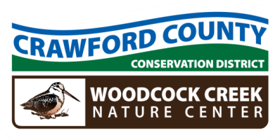

Crawford County Conservation District
Woodcock Creek Nature Center
21742 German Road – Meadville, PA 16335 – Phone: 814-763-5269
www.crawfordconservation.com

REGULAR MEETING AGENDA
Monday, March 10, 2025

4:15 P.M. CALL TO ORDER ……………….…………………………………………………………………… Waddell
4:16 INTRODUCTION OF GUEST(S) ………………………………..………………………………. Waddell
4:17 APPROVAL OF MINUTES …………………………………………………..………………… Waddell
4:18 REVIEW AND REQUEST TO FILE TREASURER’S REPORT FOR AUDIT………… Dengler
(January and February)
4:20 UNFINISHED BUSINESS
Ratify 105 Agreement with Venango County…………………………….. Crawford
4:25 NEW BUSINESS
ACAP recommendations for approval ……………………………………… Dilley
Ag Land Preservation Report ………………………………………………………. Crawford
Nutrient Management Plan Review …………………………………………. Holler
Annual NRCS Agreement review ………………………………………………. Lasko
Park Bench ………………………………………………………………………………. Crawford
4:40 STAFF FEATURE REPORT (ACAP) …………………………………………………………….. Dilley

4:50 COOPERATING AGENCY REPORTS

5:00 ADJOURN AND SIGNATURES

Next Meeting Date: April 14, 2025
All Conservation District Directors are considered Public Officials.
Statement of Financial Interest Forms Due before May 1st
Tree Sale Packing April 23, 2025 & Distribution April 25, 2025 at Fairgrounds

