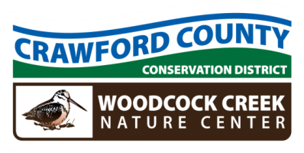

Crawford County Conservation District
Woodcock Creek Nature Center
21742 German Road – Meadville, PA 16335 – Phone: 814-763-5269
www.crawfordconservation.com

Annual Meeting
AGENDA
Thursday, February 20, 2025
Following Annual Luncheon

ESTIMATED
2:15 P.M. CALL TO ORDER ……………….……………………………………………………………………………… Waddell
2:16 APPROVAL OF MINUTES ……………………………………………………..………………………….. Waddell
2:18 REVIEW AND REQUEST TO FILE TREASURER’S REPORT FOR AUDIT………………….. Dengler
2:20 NEW BUSINESS
MOU with Venango County Conservation District……………………… Crawford/Ferguson
2:25 ADJOURN

Upcoming Meetings
DGLVR QAB: February 28, 2025 at 12:00 noon, Woodcock Creek Nature Center
CCCD Board: March 10, 2025 at 4:15 pm, Woodcock Creek Nature Center
ACAP Committee: March 4, 2025 at 10:00 am at Woodcock Creek Nature Center

All Conservation District Directors are considered Public Officials.
Statement of Financial Interest Forms Due before May 1st

