GREAT PLAINS 10’ END WHEEL NO-TILL DRILL
General Information
The Great Plains No-Till Drill is a 10-foot end wheel drill. A minimum of a 75hp tractor is required. The drill does not have a fertilizer box, and therefore, NO fertilizer should be used in the box. The drill has 2 standard seed boxes and a native grass seed box. The No-till Drill may be rented only by Crawford County residents and for use only within the county. The User/Operator must be a Pennsylvania licensed driver and submit proof along with auto insurance documents. Each operator is responsible for pick-up and return of the drill to the Conservation District office. You will need your own hitch pin. NO INTERSTATE HAULING.
Please take care of the drill as if it was your own. While the drill is on your farm it must be stored inside or covered. You will be responsible for any negligent misuse and abuse of the machine. Careless use or abuse will prohibit you from using the drill in the future. CCCD staff and user/operator will inspect the machine before pick-up and after return for general maintenance and damages. Remaining seed is to be removed from seed boxes by hand or vacuum. Do not use water to clean out the seed boxes.

Rental Costs & Information
Cost is $12.00 per acre, based on the meter reading on the drill, plus a $100 deposit due prior to use.
Scheduling Information
Scheduling is done on a first-come, first-served basis considering the location to be used. We cannot guarantee that the drill will be available on the days that you requested. To schedule the drill, you must complete a rental request form and return it with a $100 deposit fee. You WILL NOT be placed on the schedule until your deposit has been received. The deposit can be used to towards the rental fee – all or partial. If the drill is returned unclean or damaged, the user may lose all or part of their deposit. The term of rental is 3 days and 2 nights; after which there will be a $25/day late fee beginning on the 4th day after pick-up. If there is inclement weather, please contact the District promptly. We will notify you when the drill is ready for pick up and each operator is responsible for pick up and return to the District. Due to changes in weather, we will do our best at scheduling you for you chosen dates. If your field is not ready for planting, call the District Office. Scheduling could be adjusted to accommodate for the delay.
The final payment is due at the time you are finished using the no-till drill. Make checks payable to: Crawford County Conservation District

GREAT PLAINS NO-TILL DRILL RENTAL AGREEMENT
THIS _________ DAY OF _____________________, 20____
BY AND BETWEEN:
User/Operator: _________________________________________________________________
Address: ______________________________________________________________________
City: __________________________________ State: ______________ Zip: ______________
Phone: __________________________________ Alt. Phone: ___________________________
Email: ________________________________________________________________________
Location of no-till drill use:
______________________________________________________________________________
AND
THE CRAWFORD COUNTY CONSERVATION DISTRICT, hereinafter “Owner”, having an office at 21742 German Road Meadville PA 16335 814-763-5269.
AND NOW IN CONSIDERATION OF THE FOREGOING, the Parties agree as follows:
DATES OF USE: __________________________
# of Acres and Type of Planting: ___________________________________________________
Truck/Auto Insurance Carrier: _____________________________________________________
Tractor Make, Model, Horsepower: _________________________________________________
NOTE: Attach copy of PA Driver’s license
User acknowledges that the Great Plains 10’ End Wheel No-Till Drill requires at least a 75-
horsepower tractor to operate safely, and as the manufacturer’s recommendation, the User will do so.
_____________
User acknowledges that they have received and reviewed the owner’s manual
_____________
GREAT PLAINS NO-TILL DRILL RENTAL AGREEMENT - RELEASE

User accepts the responsibility for all damages caused by negligence or careless use, and misuse
of this equipment to include, but not limited to, all repairs and replacement of any non-wear and
parts.
The Crawford County Conservation District, does not accept any
responsibility or liability for the use of the Drill by the user. The User, by signing this form,
accepts all responsibilities for towing the Drill over public and private roads. The User, or User’s
insurer, will be solely responsible for damages caused during towing.
USER HEREBY RELEASES, WAIVES, DISCHARGES, AND COVENANTS NOT TO SUE
the Owner, or any agents thereof, including their directors, officers, agents, employees,
representatives, owners, members, affiliates, land owners, owners, successors and assigns all for the purposes herein referred, FROM ALL LIABILITY TO THE UNDERSIGNED, its personal
representatives, assigns FOR ANY AND ALL LOSS OR DAMAGE AND ANY CLAIM OR
DEMANDS THEREFORE ON ACCOUNT OF INJURY TO THE PERSON OR PROPERTY OR
RESULTING IN DEATH OF THE UNDERSIGNED ARISING OUT OF OR RELEATED TO
THE EVENT(S), WHETHER CAUSED BY THE NEGLIGENCE OF THE COUNTY OR
OTHERWISE. USER ACKNOWLEDGES THAT HE/SHE ALONE WILL OPERATE THIS
MACHINERY AND THE TRACTOR UTILIZED WITH THIS DRILL.
USER HEREBY ASSUMES FULL RESPONSIBILTY FOR ANY RISK OF BODILY
INJURY, DEATH OR PROPERTY DAMAGE arising out of or related to the equipment.
AGREED:
User Signature: ____________________________________________ Date: _______________
User Name Printed: _________________________________________
Witness Signature: _________________________________________ Date: ________________
Witness Name Printed: ______________________________________
GREAT PLAINS NO-TILL DRILL CHECKLIST – OFFICE USE ONLY
Check dates on calendar
Read over contract with renter, provide copy
3 day – 2-night rental contract
Clean out seed boxes by hand or with a vacuum – do not use water
Call the district if using more than original 3 days
Collect $100.00 deposit check. +$12/acre
Obtain copy of Auto Insurance (The card you keep in your car will work.)
Obtain copy of users PA driver’s license
They need a minimum 75 horsepower tractor
Make sure everything is filled out and signed
20 MPH with a shadow vehicle
Reese Hitch – drawbar hitch (not a ball)
Please check the following after use:
All bolts tightened: Yes____
Seeder Usage Manuals: Yes____
Seed Boxes Cleaned Out: Yes___
Graphite: Yes ___
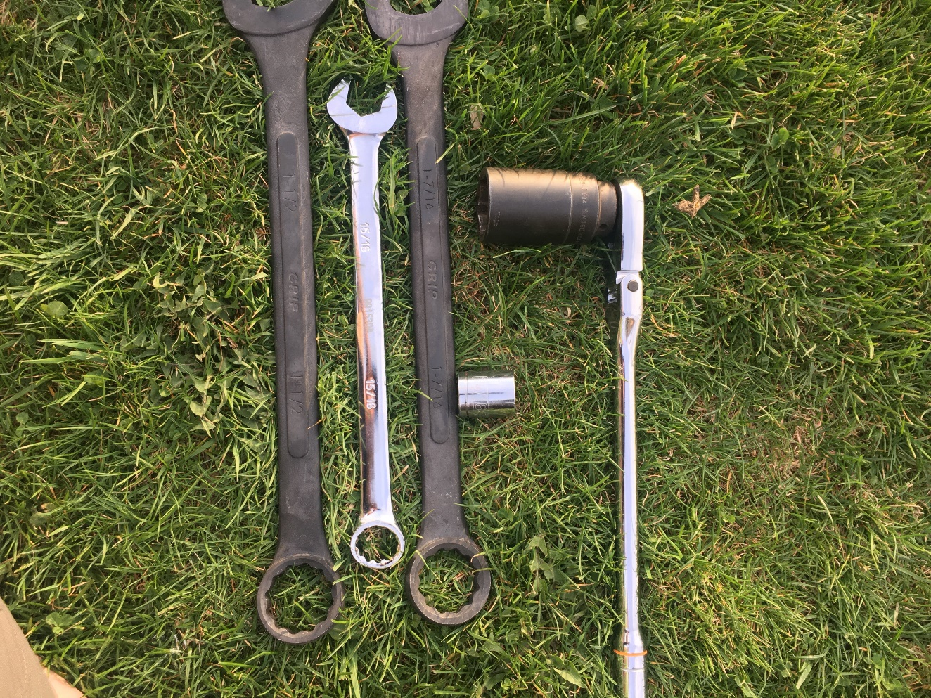
1 ½ 15/16 1 7/16
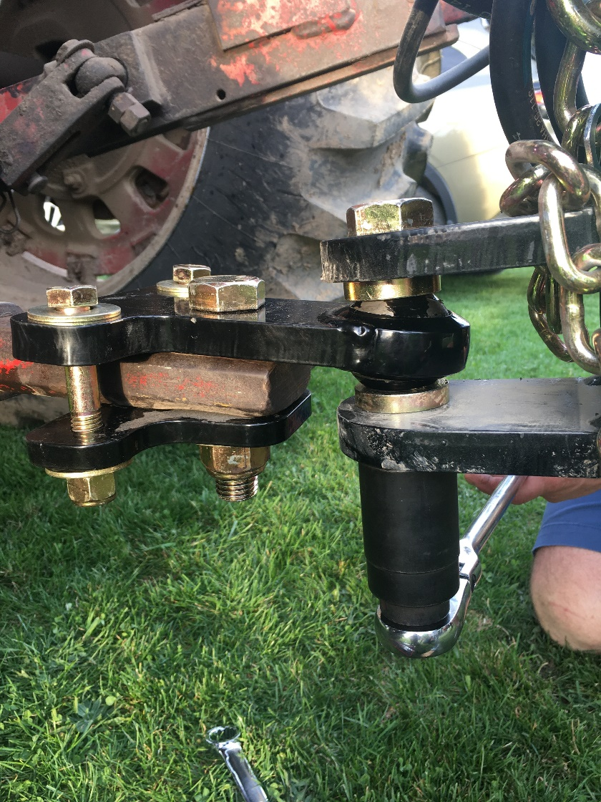

https://extension.psu.edu/grain-drill-calibration
